Maximizing Employee Engagement

Participant Guide

This page left intentionally blank.
Front Matter
United States
Office of Personnel Management
Executive Services
Senior Executive Service & Performance Management
1900 E Street, NW
Washington, DC 20415

This page left intentionally blank.

Table of Contents
Participant Information 1
Ground Rules 1
Your Participant Guide 2
Course Agenda 2
Section 1: Course Content 4
Introduction 5
Factors that Influence Engagement 9
Overview of Engagement 10
You and Your Employees’ Engagement 15
Activity: Factors that Influence Your Engagement 17
Activity: Challenges that Influence Your Employees’ Engagement 19
Matching Motivators to Individuals 22
Job Characteristics 23
Activity: Different Strokes for Different Folks 27
Activity: Different Strokes for Different Folks, continued 28
Leadership Styles 31
Activity: Matching your Leadership Style to the Situation 34
Activity: Matching your Leadership Style to the Situation, continued 36
Activity: Matching your Leadership Style to the Situation, continued 38
Barriers to Engagement 40
Interpersonal Barriers 41
Activity: Your Interpersonal Barriers 43
Activity: Role Play Action Plan 46
Organizational Barriers 49
Develop an Action Plan 53
Action Plan 54
Activity: Develop Your Action Plan 57
Conclusion 59
Section 2: Job Aids 63
Job Aid: Debunking Myths about Employee Engagement 65
Job Aid: Ways to Create a Culture of Engagement 67
Job Aid: Fast Track to Lowering Engagement 68
Job Aid: Other Government Agencies’ Strategies to Drive an Engaged Organizational Culture 70
Job Aid: Alternative Non-monetary Ways to Encourage Training and Development 76
Section 3: Supplemental Reading and References 78
Supplemental Reading 80
References 81

Participant Information
Welcome to the Maximizing Employee Engagement course! This is a companion to the 60-minute Maximizing Employee Engagement web-based training (WBT) course, which is accessible on OPM’s HR University (http://hru.gov) and OPM’s Training and Development Wiki (http://www.opm.gov/wiki/training/index.aspx). This instructor-led course is intended to supplement the information provided in the WBT by using activities and discussions to reinforce learning. If you have not already, we recommend that you take the 60-minute WBT course.
In this Participant Guide you will find the course guidelines and content, copies of the PowerPoint slides with room on each page for notes, and copies of all activities and job aids, to include an action plan table for you to use in support of your engagement efforts.

Ground Rules
During this course everyone is asked to:
- Participate
- Be on time
- Stay on task
- Share responsibility for training
- Listen when others talk
- Respect the opinions and attitudes of others
- Turn off cell phones and mobile devices
- Use flip chart Parking Lot items
Importantly, this is a safe place to share your ideas and thoughts.
Give constructive feedback, suggestions, and other responses to other participants during the activities and discussions.
However, try to keep your comments, questions, and discussion on track with the lesson topic; avoid digressions and tangents.

Your Participant Guide
Your Participant Guide is organized into three sections:
- Section 1: Course Content includes the PowerPoint slides with space for notes and all course activity materials
- Section 2: Job Aids includes all of the job aids used in the course
- Section 3: Supplemental Reading and References

Course Agenda
The sequence of lessons, topics within each lesson and the estimated instructional time (reported in minutes) for the course is as follows:
Lesson and Topic Titles | Estimated Time (minutes)
Introduction | 20
Factors that Influence Engagement | 60
Overview of Engagement | 20
You and Your Employees’ Engagement | 40
Matching Motivators to Individuals | 75
Job Characteristics | 45
Leadership Styles | 30
Barriers to Engagement | 65
Interpersonal Barriers | 45
Organizational Barriers | 20
Develop an Action Plan | 30
Conclusion | 5
Total | 255 (or 4.5 hours)
Breaks will be scheduled throughout the course.

This page left intentionally blank.

Section 1: Course Content

Introduction
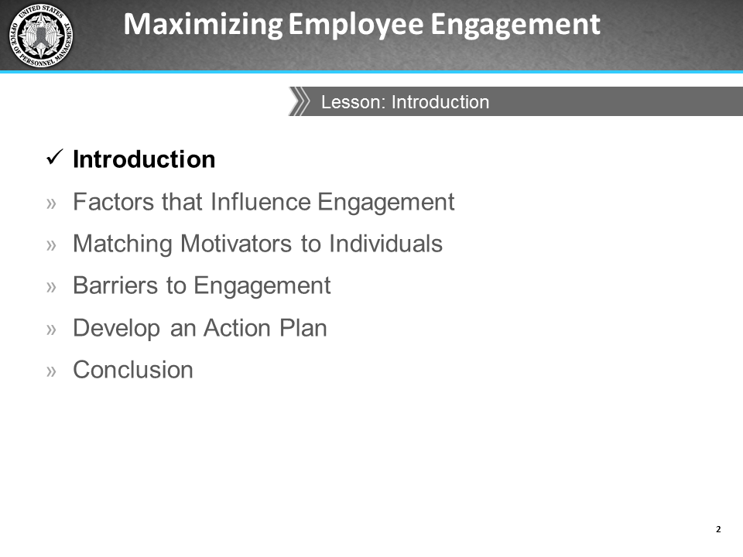
Notes:
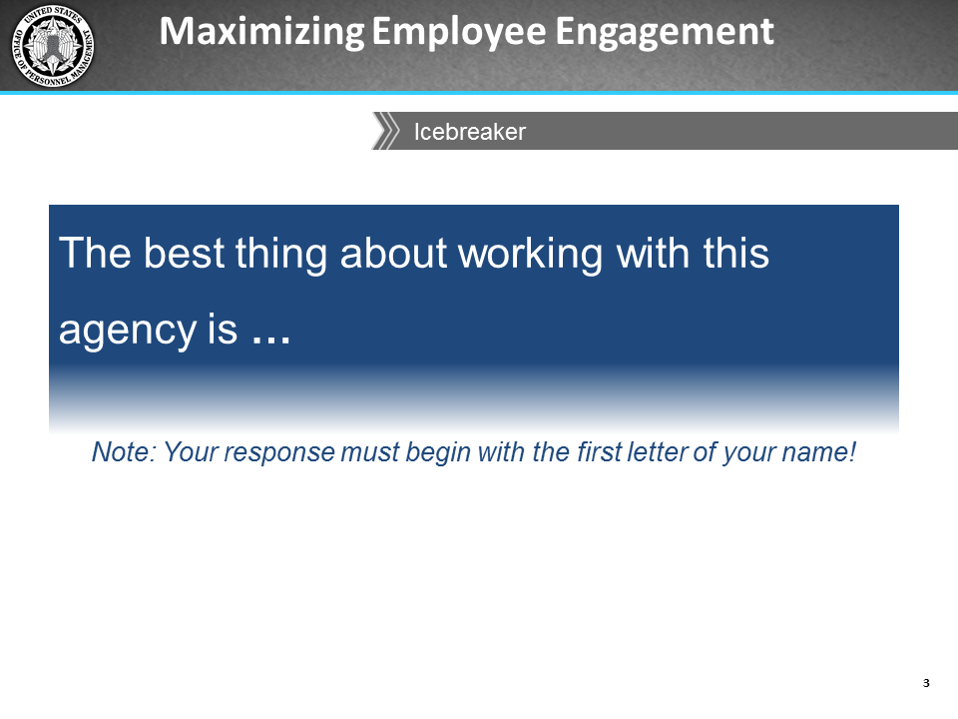
Notes:
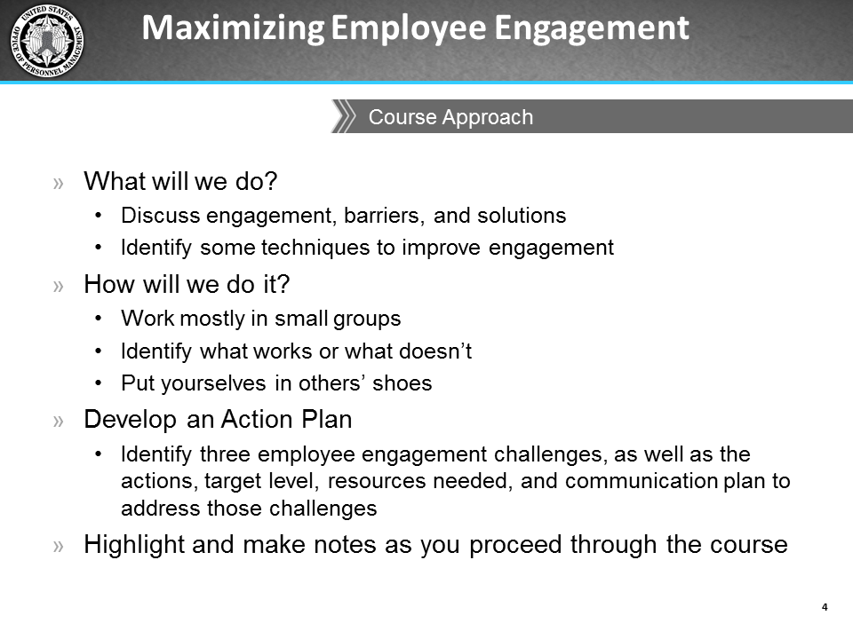
Notes:
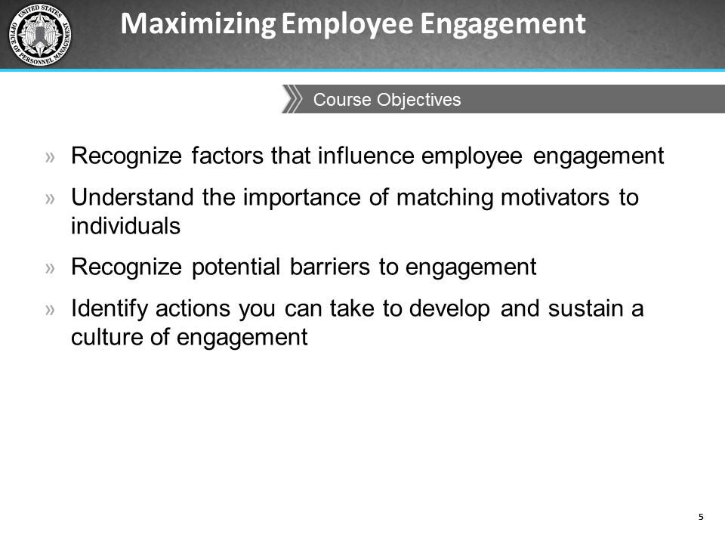
Notes:

Factors that Influence Engagement
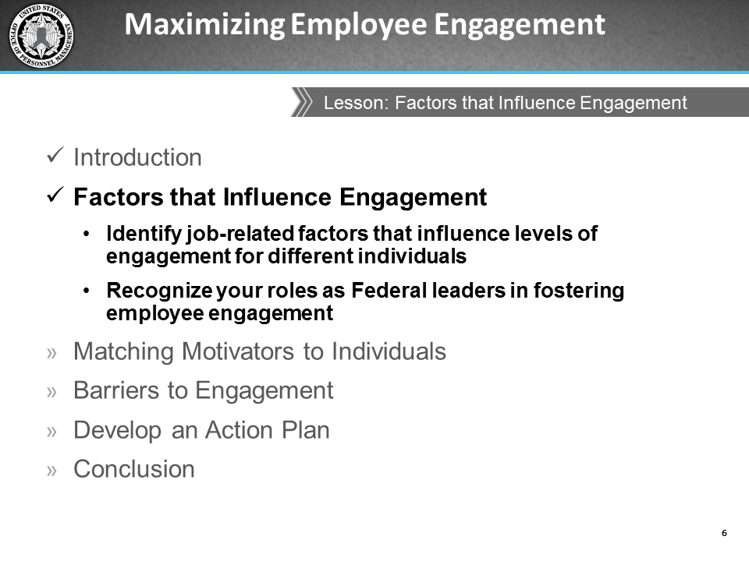
Notes:

Overview of Engagement
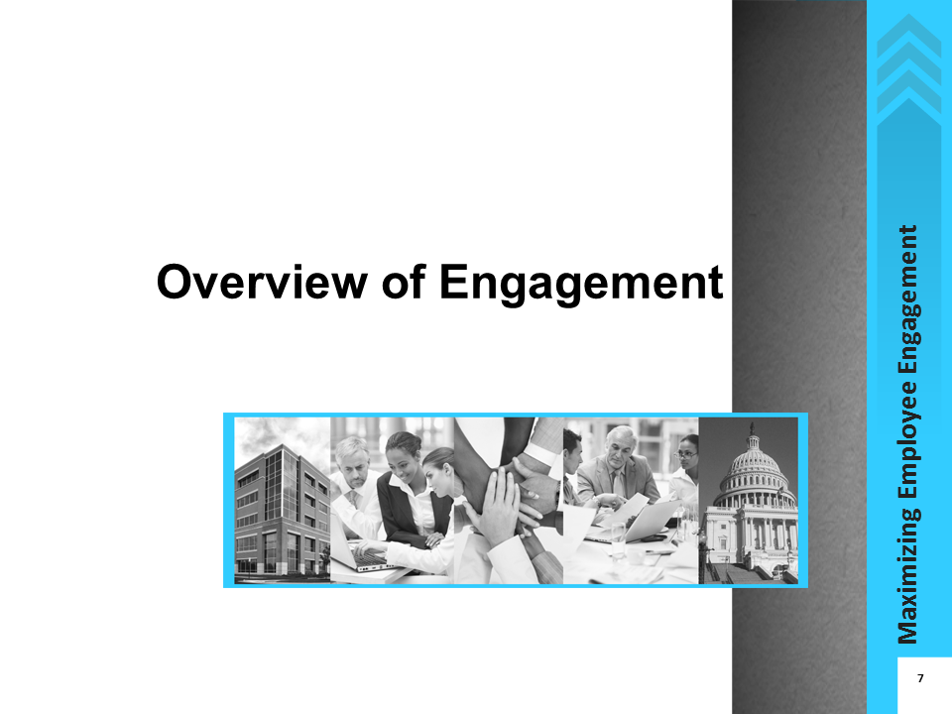
Notes:
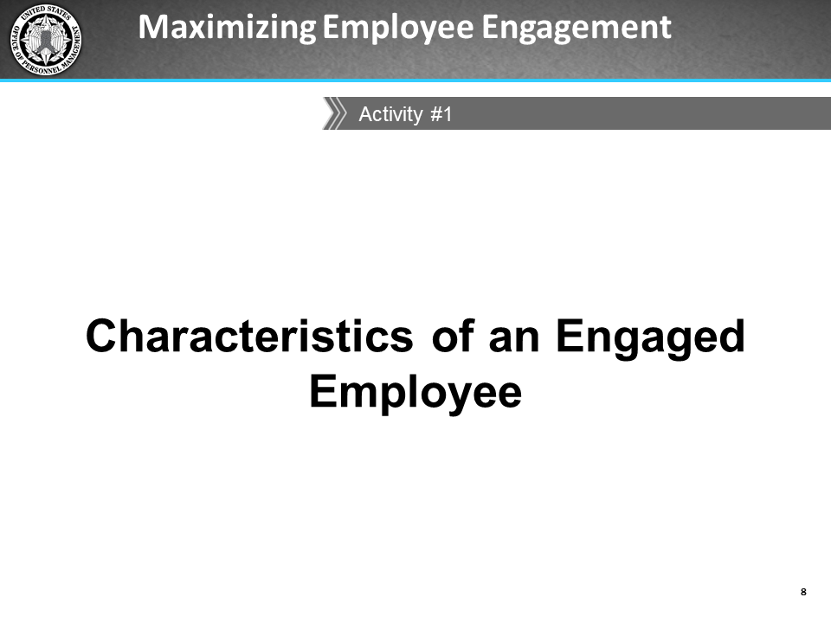
Notes:
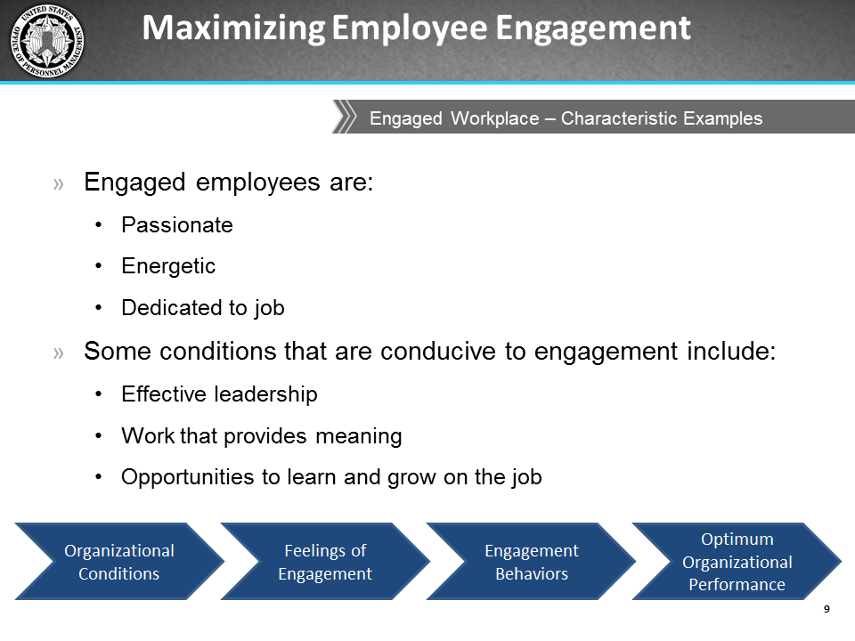
Notes:
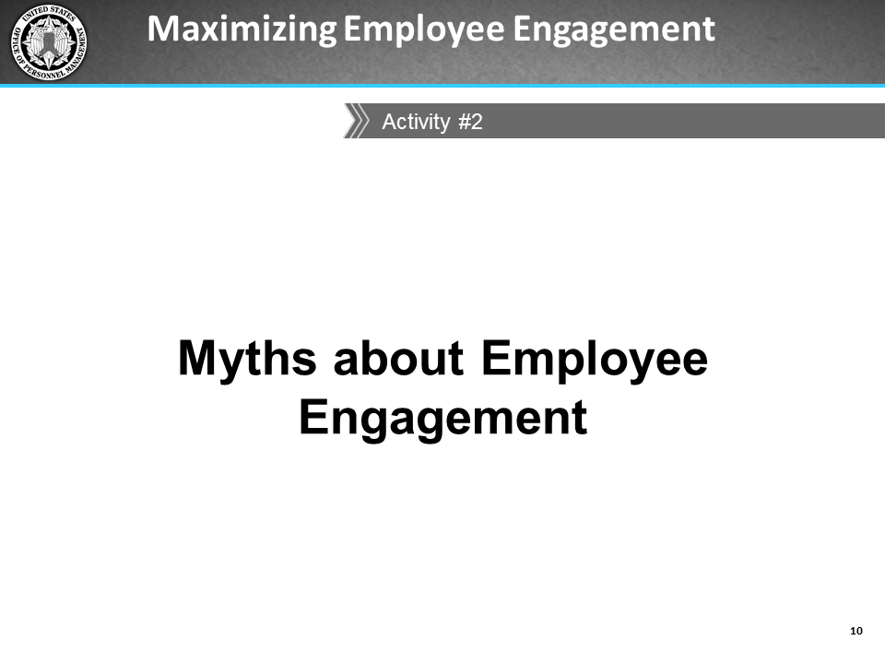
Notes:
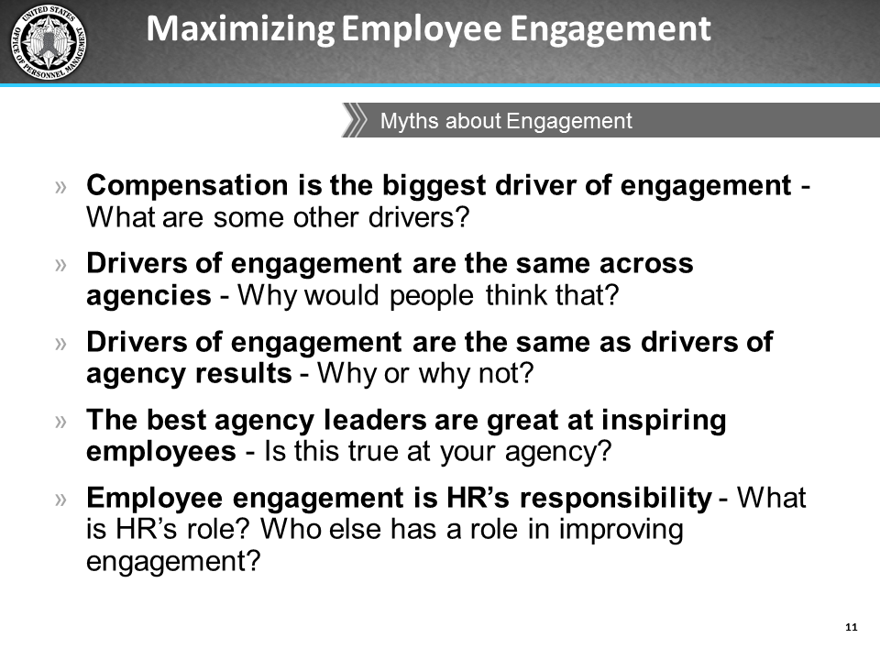
Notes:

You and Your Employees’ Engagement
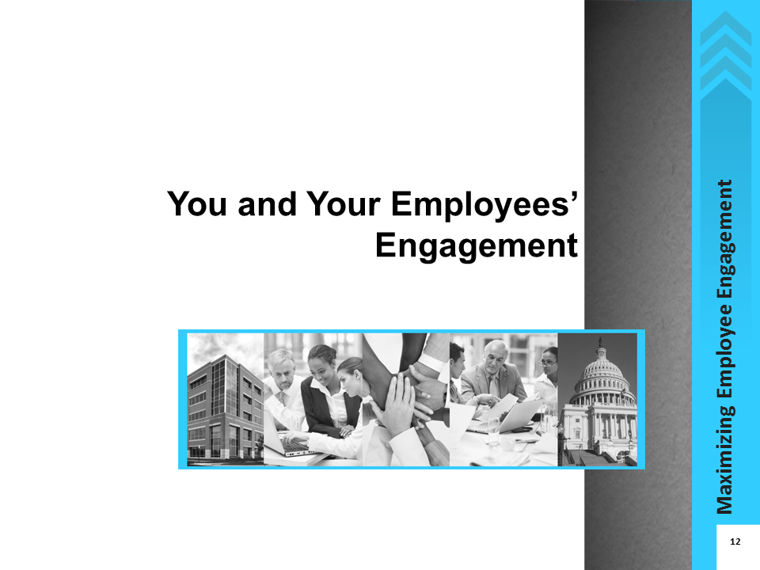
Notes:
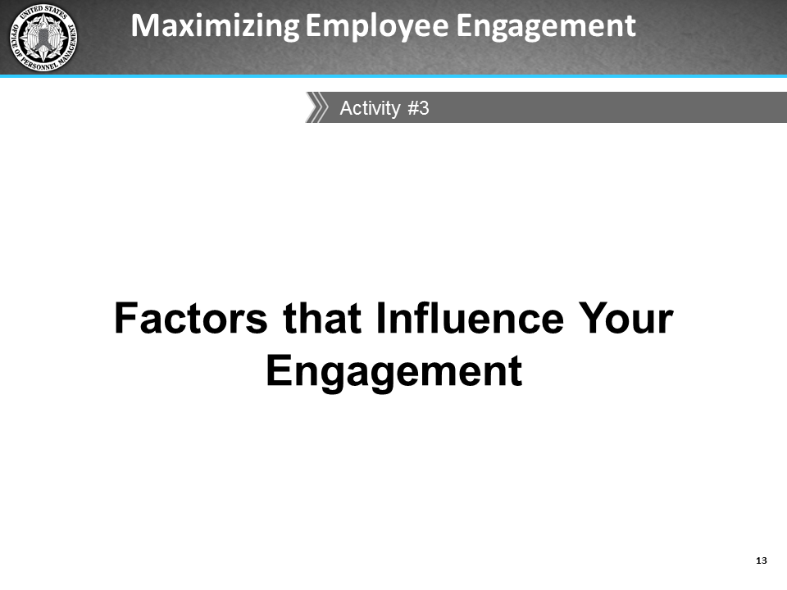
Notes:

Activity: Factors that Influence Your Engagement
Reflect on a time when you felt engaged and/or disengaged at work. What kinds of factors in your work environment promoted or hindered your engagement?
Factors that Influence Your Engagement | Did it promote or hinder your engagement?

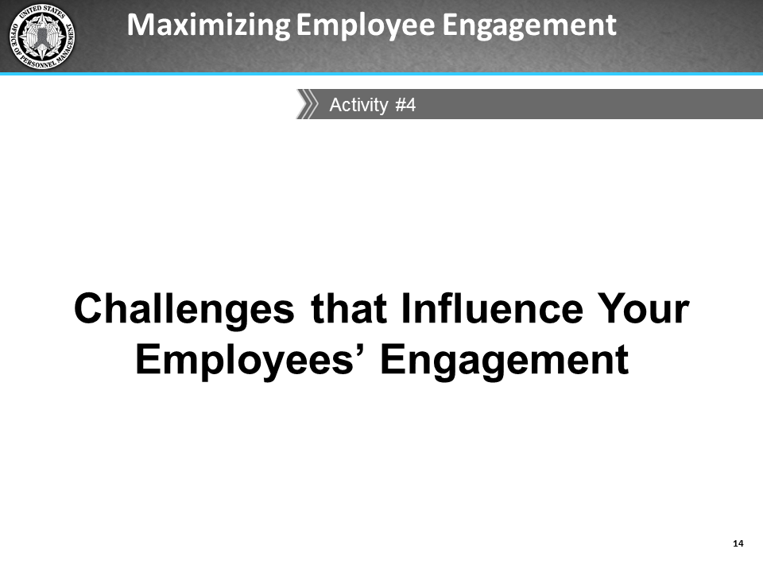
Notes:

Activity: Challenges that Influence Your Employees’ Engagement
Think back to before you became a supervisor. What challenges did you have with your manager or supervisor that affected your engagement?
Today, as a supervisor, what are some of the specific challenges to engagement you have seen among your employees? Write these responses in the first column below.
Discuss your responses to these questions within your small group and designate a group member to be the reporter. As a class, we will help each other identify possible solutions to overcome each challenge.
Challenges that Influence Your Employees’ Engagement | Possible Solutions to the Challenges

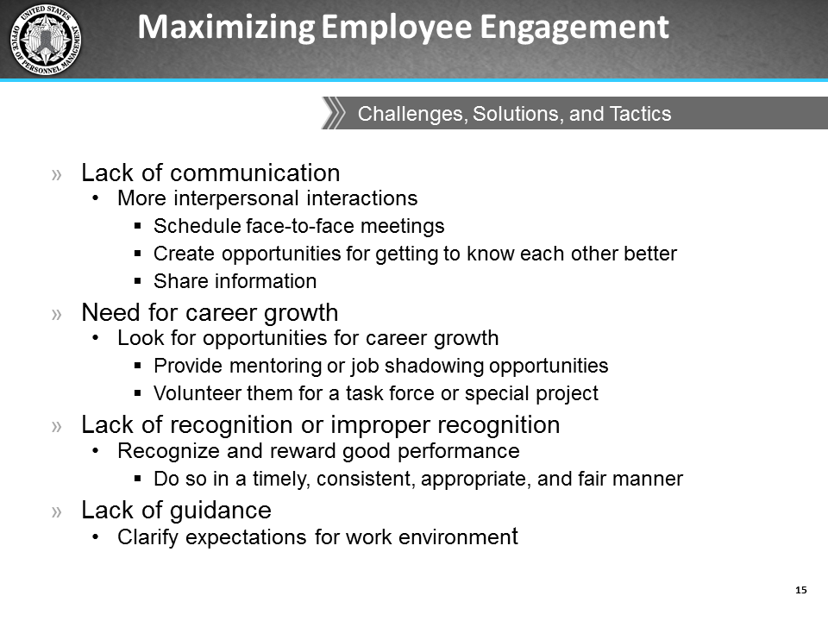
Notes:
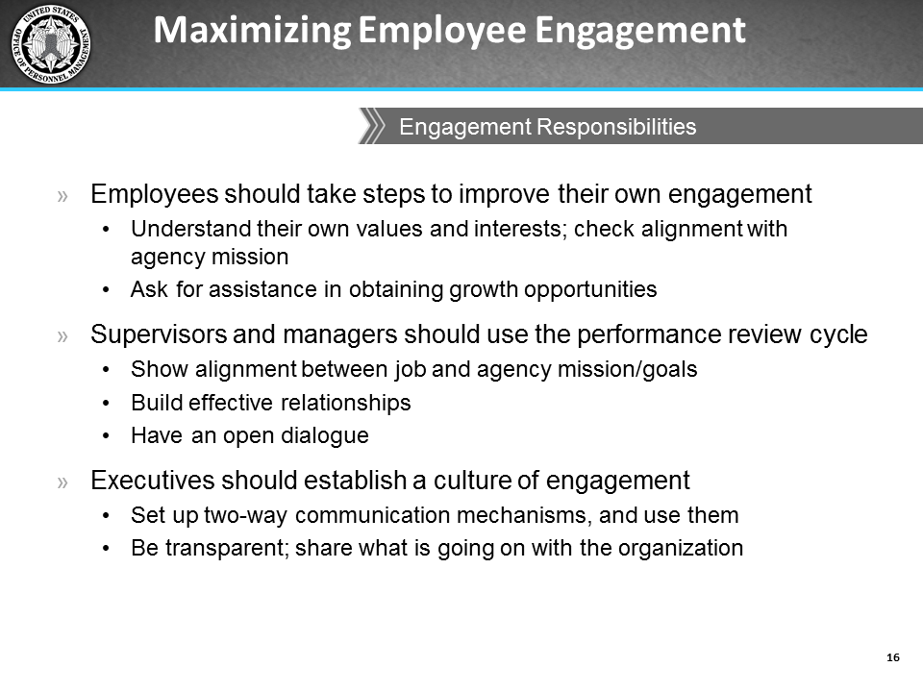
Notes:

Matching Motivators to Individuals
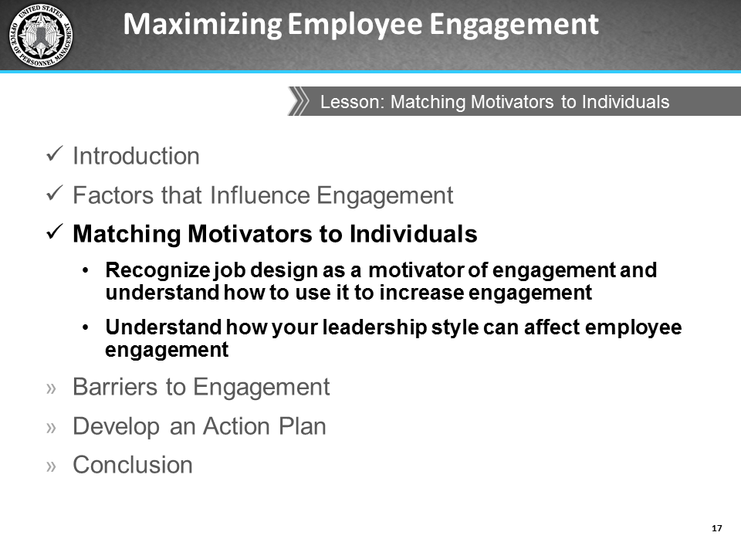
Notes:

Job Characteristics
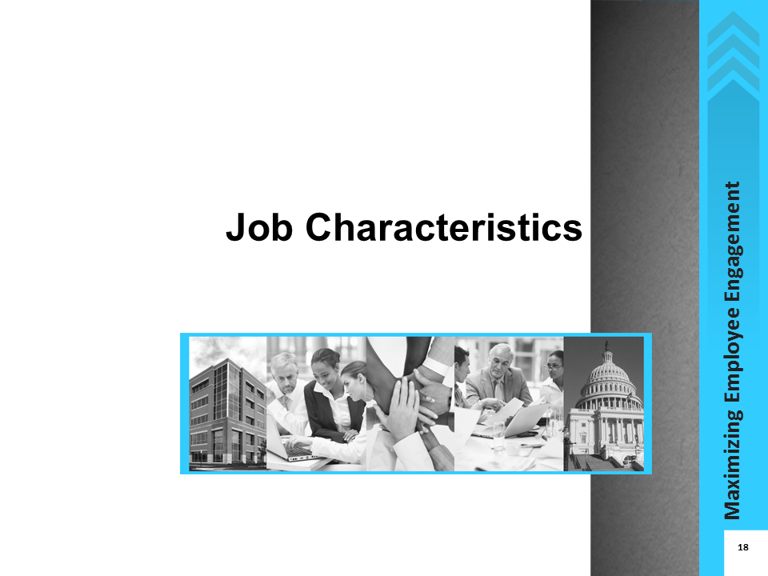
Notes:

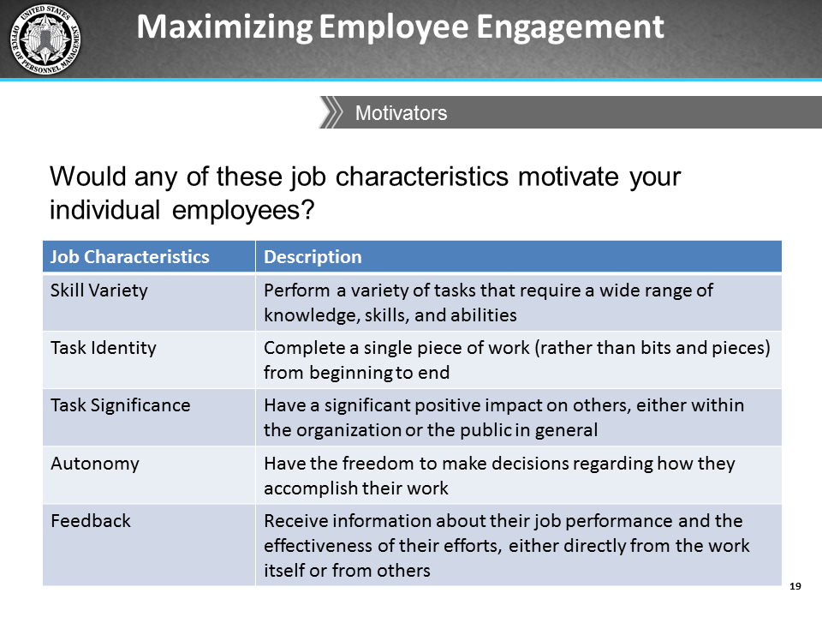
Notes:
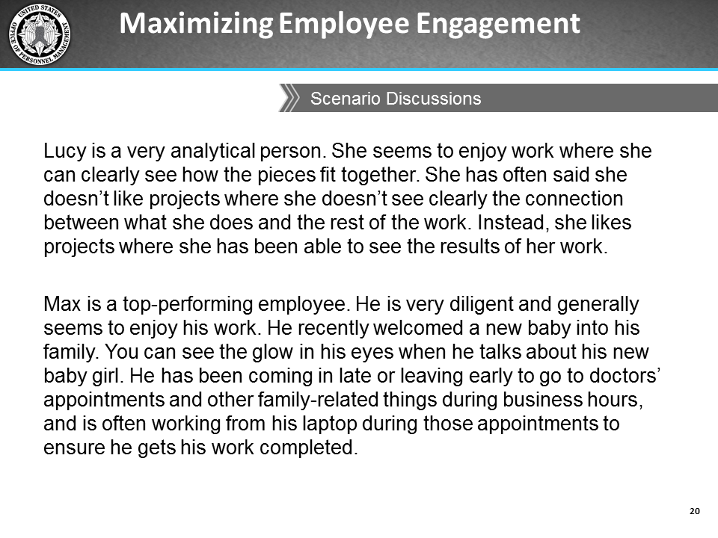
Notes:
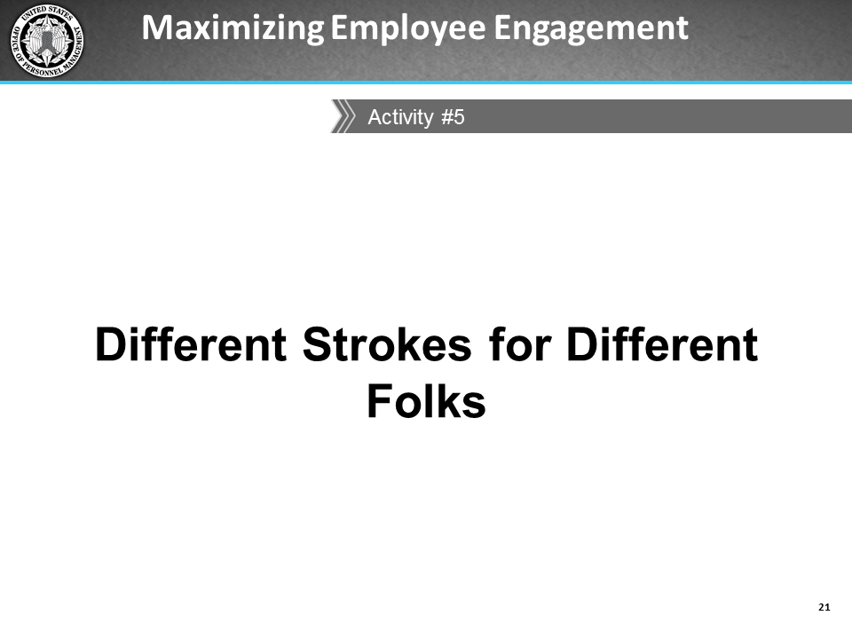
Notes:

Activity: Different Strokes for Different Folks
PART 1
Ask yourself these questions to gauge which job characteristics might best motivate your employees.
Job Characteristics | Is the employee likely to be satisfied with …
Task Identity | The degree to which the job provides for completion of a whole and identifiable piece of work from beginning to end?
Task Significance | The difference he or she can make to others through the job?  The importance of the job compared to other jobs in the organization?
Autonomy | The level of independence and discretion allowed in making decisions about work sequence, methods, procedures, or quality control?
Skill Variety | The variety of knowledge, skills, and abilities required?
Feedback | - The clarity of performance expectations (for example, quality, timeliness)?  - The availability of feedback about job performance?  - The frequency of performance feedback?  - Access to communication channels and flows of information?

Activity: Different Strokes for Different Folks, continued
PART 2
For each job characteristic noted in the first column, describe how much authority (i.e., No authority, Minimal authority, Some authority, or Full authority) you think you have to make modifications to each of them for your employees, as well as how you would go about modifying the job characteristic to enhance engagement.
In addition to keeping in mind the individual employees you manage, also think about the nature of the work your team usually performs, human resource policies, the needs of the organization, and the imperative to be fair, objective, and transparent while you consider modifying job characteristics.
Job Characteristics | How much authority do you have to modify this characteristic? | How would you modify the job characteristic?
Task Identity
Task Significance
Autonomy
Skill Variety
Feedback

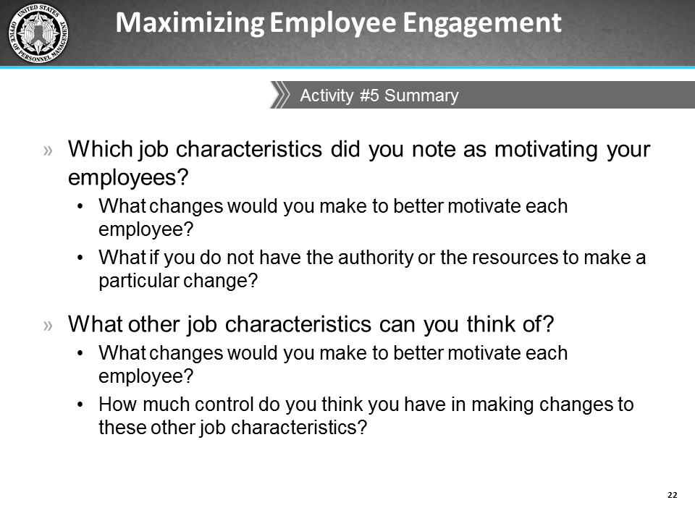
Notes:

Leadership Styles
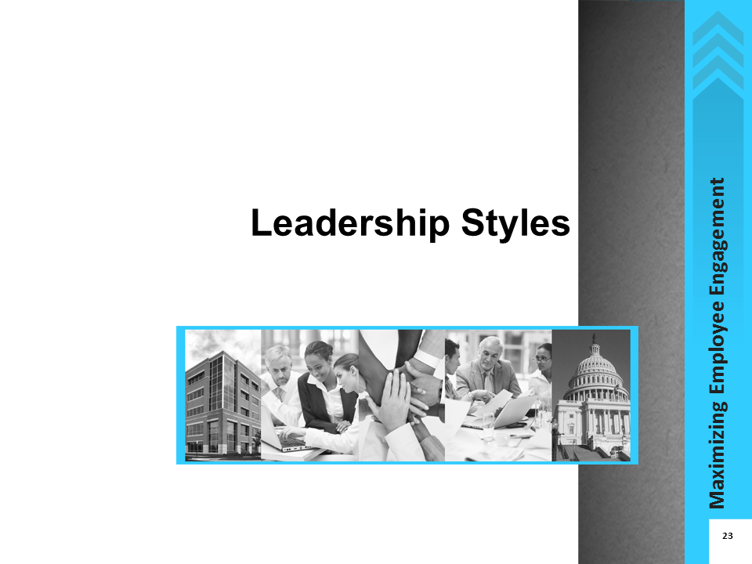
Notes:

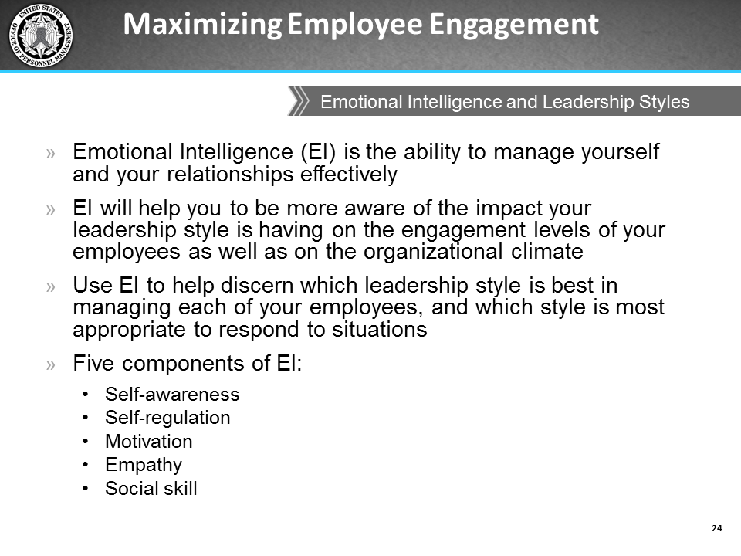
Notes:
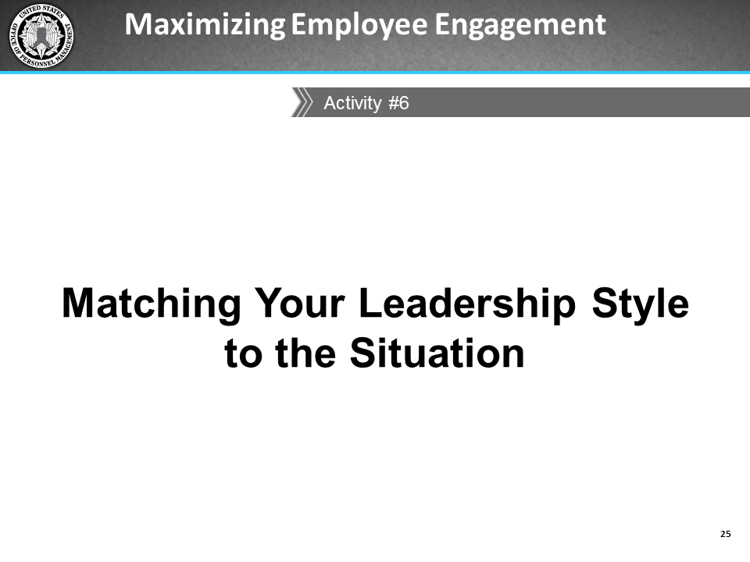
Notes:

Activity: Matching your Leadership Style to the Situation
Goleman’s Six Leadership Styles
Characteristics | Coercive | Authoritative | Affiliative | Democratic | Pacesetting | Coaching
Leader’s modus operandi | Demands immediate compliance | Mobilizes people towards a vision | Creates harmony and builds emotional bonds | Forgoes consensus via participation | Sets high standards for performance | Develops people for the future
The style in a phrase | ‘Do what I tell you’ | ‘Come with me’ | ‘People come first’ | ‘What do you think?’ | ‘Do as I do, now’ | ‘Try this’
Underlying emotional Intelligence | Drive to achieve, initiative, self-control | Self-confidence, empathy, change catalyst | Empathy, building relationships, communication | Collaboration, team leadership, communication | Conscientious, drive to achieve, initiative | Developing others, empathy, self-awareness
When the style works best | In crisis; to kick start a turnaround; with problem employees | When changes require a new vision, or when a clear directive is needed | To heal rifts in a team or to motivate people during stressful circumstances | To build buy-in or consensus, or to get input from valuable employees | To get quick results from a highly motivated and competent team | To help an employee improve performance or develop long-term strengths
When the style might fail | When there is not a lot of emotional self-control | When trying to motivate more experienced experts or peers on the team | When there is avoidance of emotionally distressing situations | When there is a lot of listening and discussion but very little action | When very little guidance is given to the team on how to achieve results | When micromanaging

Activity: Matching your Leadership Style to the Situation, continued
Instructions: Below is a list of situations. For each situation, indicate which leadership style you would typically use and explain why this would be the most effective leadership style. Consider factors such as your underlying emotions, your goal in that situation, and the overall impact on the climate your style might have. Be prepared to share your responses during the follow-up discussion of this activity.
Situation | Response
Agency leaders have formed a task force to uncover reasons for the low EVS engagement scores. They want at least one junior member from your team to be on the task force. However, none of your employees are interested in being on the task force. What leadership style do you use to assign an employee to the task force?
You have been assigned to lead the new employee engagement task force, but were given no guidance by senior leaders on how to proceed. What leadership style do you use to get buy-in from the task force?
Your task force is made up of members who do not know, or trust each other, and some members appear to be resistant to being on the task force. What leadership style to you use to ensure the work gets done?
The task force needs to quickly deliver and present their findings about reasons for the low EVS scores to agency leaders. What leadership style do you use to assign roles to the presenters?
Your task force presented recommendations to senior leadership. Some of your team had not prepared properly and the quality of the presentation suffered. What leadership style do you use to provide your team with performance feedback after the presentation?
As a result of the recommendations made by the committee, senior leaders have designated your work group to be part of a pilot test to try out new work procedures. You need all of your employees to buy into this plan as people are generally uncomfortable with change. What leadership style do you use to motivate your employees to participate?

Activity: Matching your Leadership Style to the Situation, continued
Components of Emotional Intelligence
EI Component | Description
Self-awareness | - Self-confidence  - Realistic self-assessment  - Self-deprecating sense of humor  - Thirst for constructive criticism
Self-regulation | - Trustworthiness  - Integrity  - Comfort with ambiguity and change
Motivation | - A passion for the work itself and for new challenges  - Unflagging energy to improve  - Optimism in the face of failure
Empathy | - Expertise in attracting and retaining talent  - Ability to develop others  - Sensitivity to cross-cultural differences
Social Skill | - Effectiveness in leading change  - Persuasiveness  - Extensive networking  - Expertise in building and leading teams

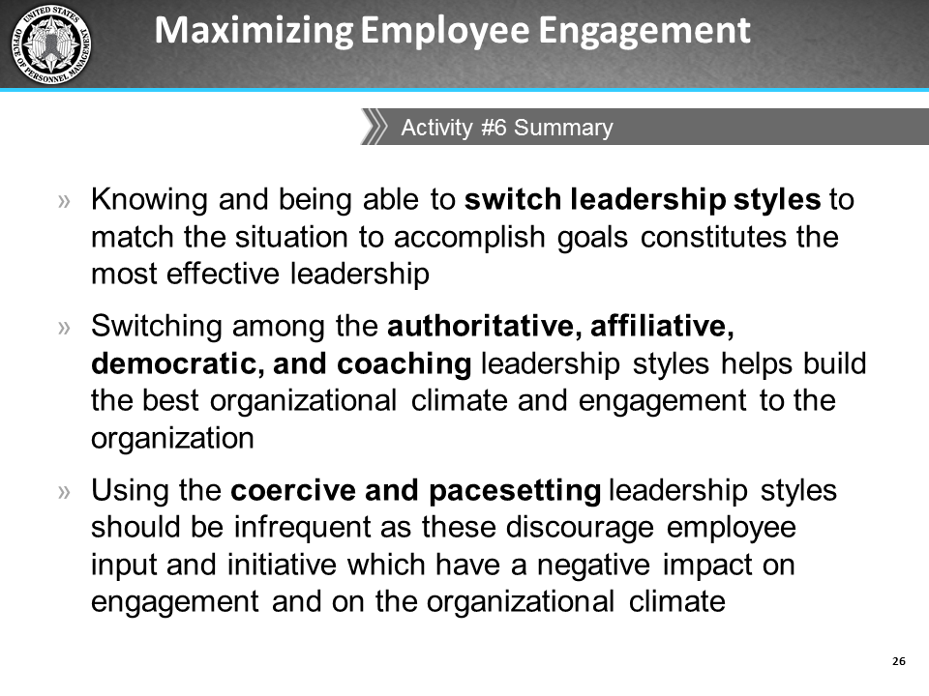
Notes:

Barriers to Engagement
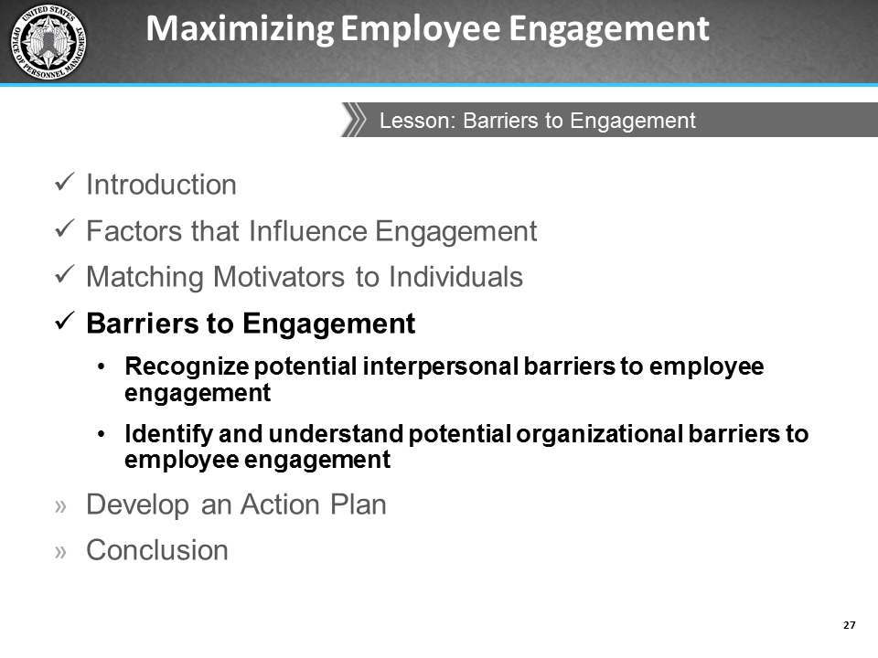
Notes:

Interpersonal Barriers
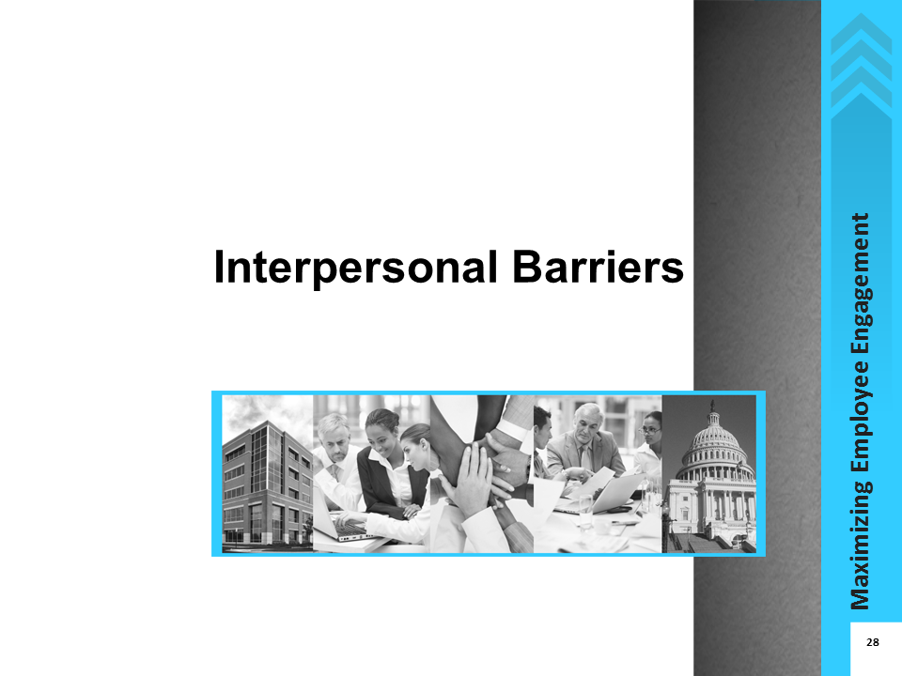
Notes:

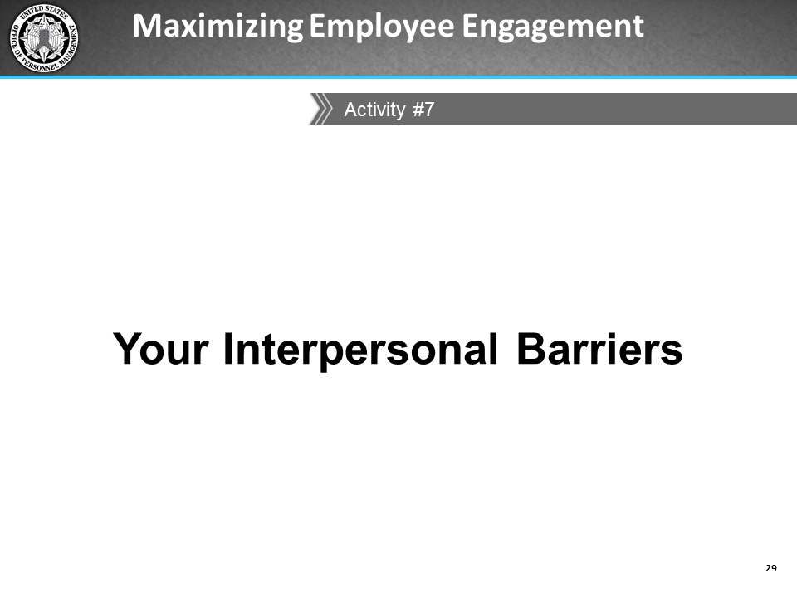
Notes:

Activity: Your Interpersonal Barriers
Take a few moments to think about some of the interpersonal barriers that exist in your interactions with your employees. Use “I” statements to write down these barriers. For example:
- I have a hard time giving negative feedback.
- I don’t communicate because I assume my employees will handle issues on their own; I don’t want to seem like a micro-manager.
When you are finished writing these “I” statements, reflect on the impact these barriers have on your communication style and list solutions to minimize these barriers.
Your Interpersonal Barriers | Solutions to Interpersonal Barriers
I …
I …
I …
I …
I …
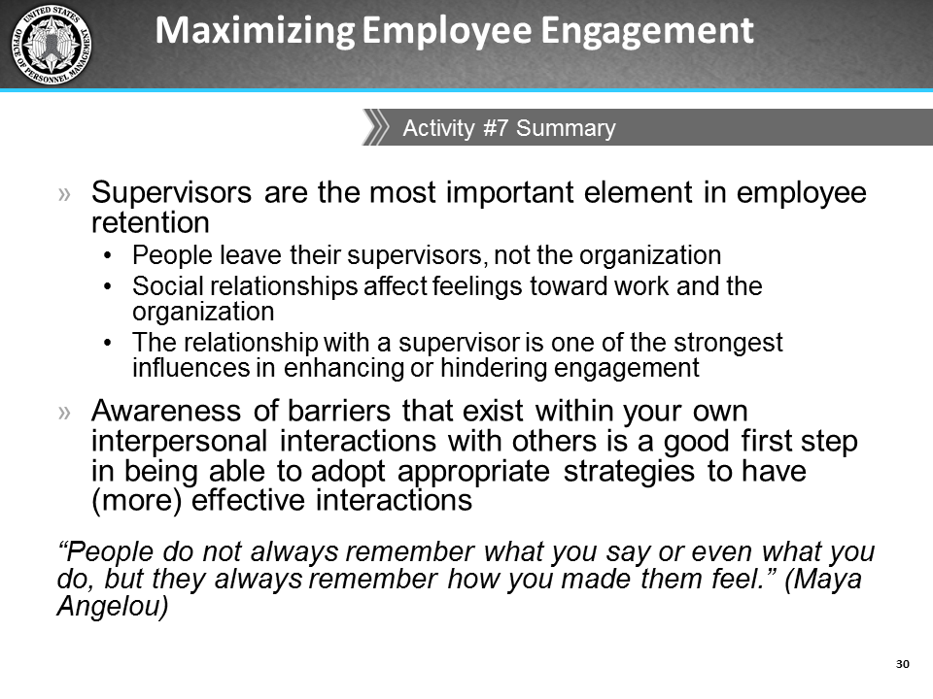
Notes:
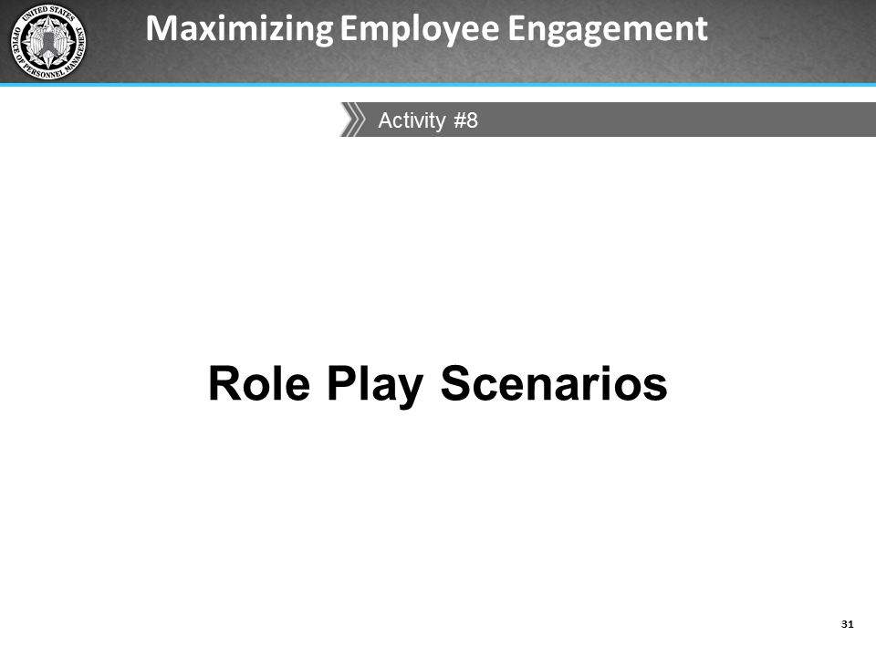
Notes:

Activity: Role Play Action Plan
Based on the results from the EVS, develop a list of 2-3 actions to improve engagement in your department.
Specific Challenges | Proposed Action | Due Date | Resources (e.g., money, staff) | Communication (who should know)
I …
I …
I …
Reflection Activity
Thinking about your employees, how do you think interacting with them with your usual leadership style might be affecting their engagement with you, other team members, and the organization?

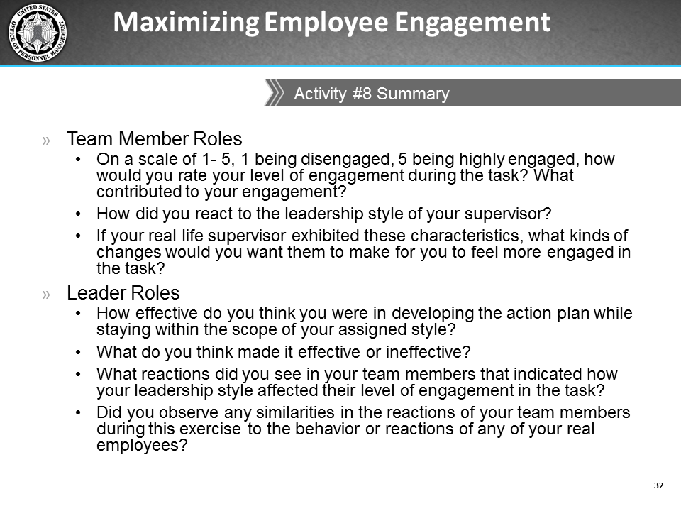
Notes:
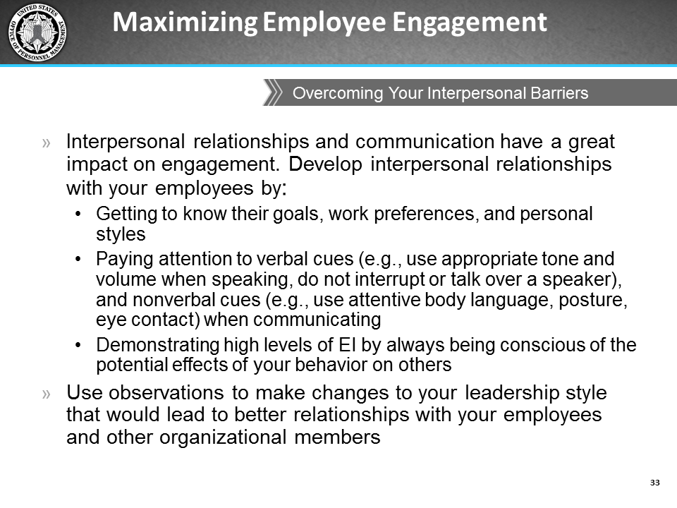
Notes:

Organizational Barriers
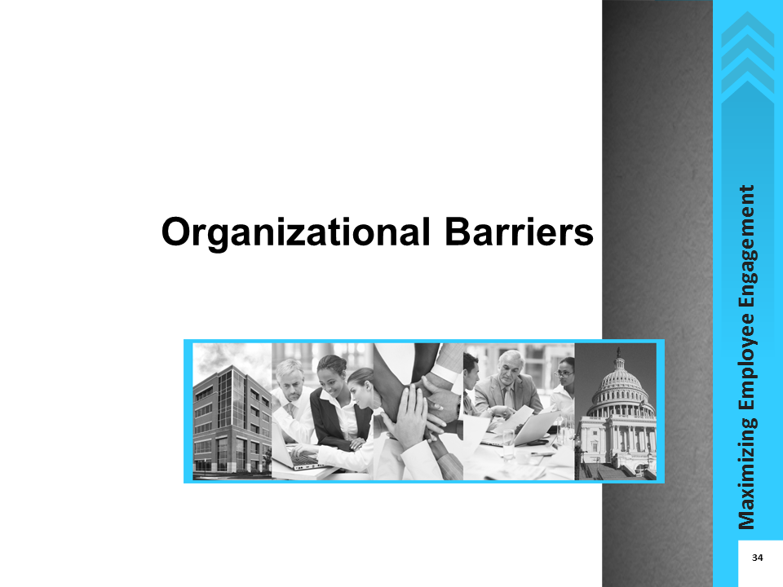
Notes:
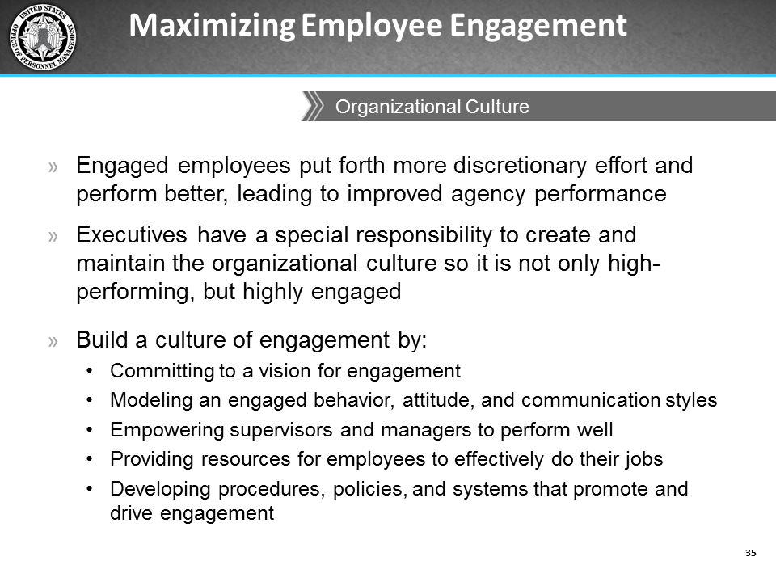
Notes:
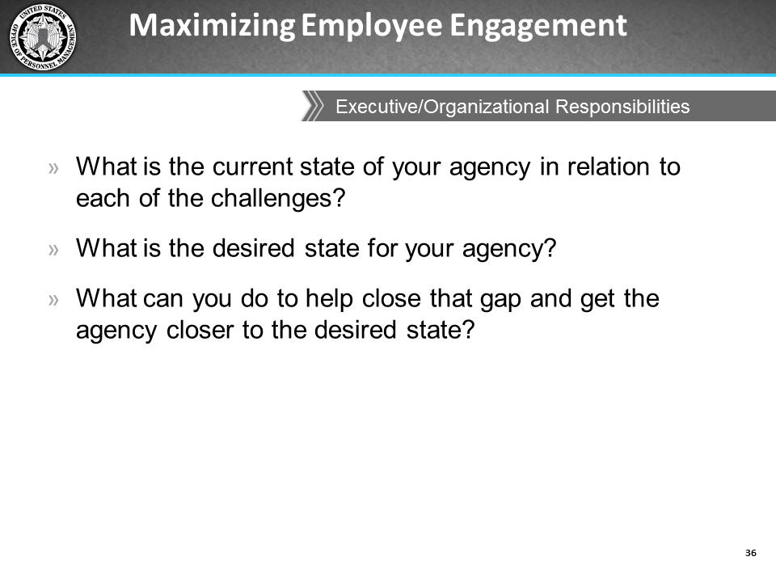
Notes:
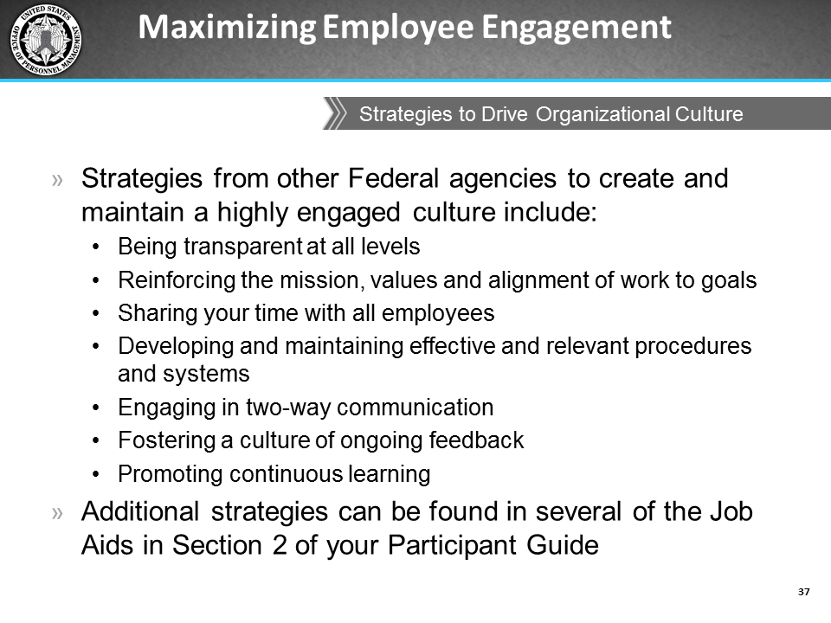
Notes:

Develop an Action Plan
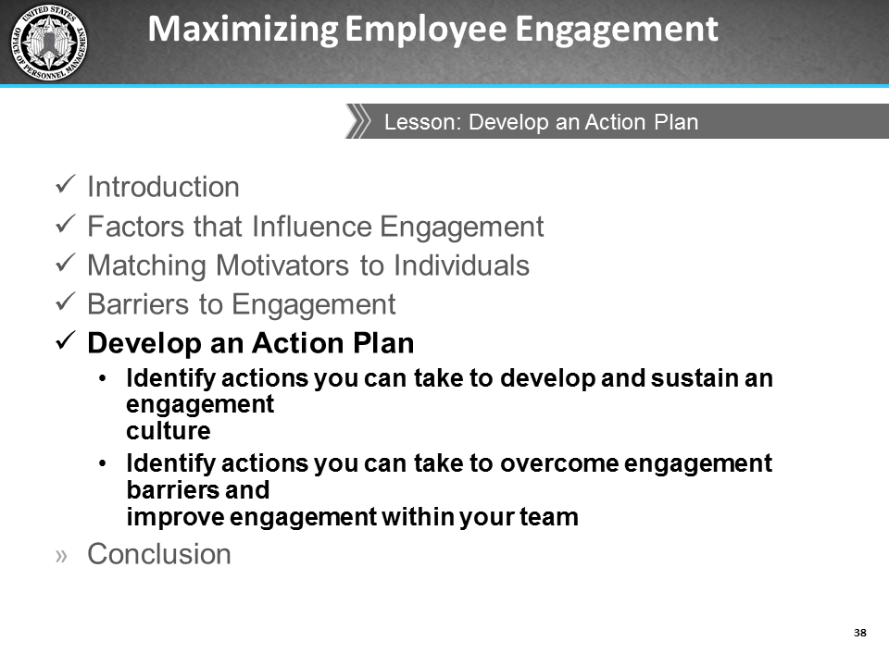
Notes:

Action Plan
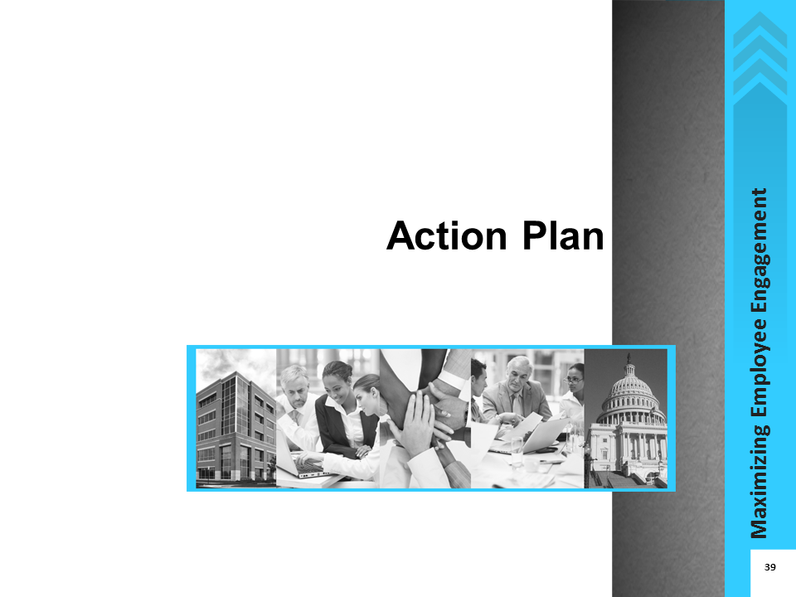
Notes:

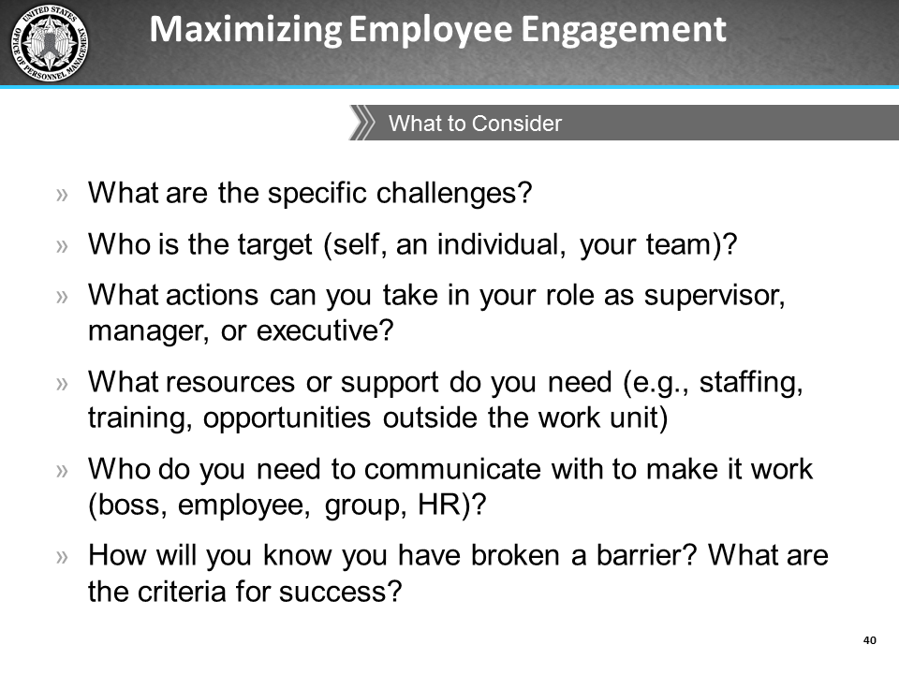
Notes:
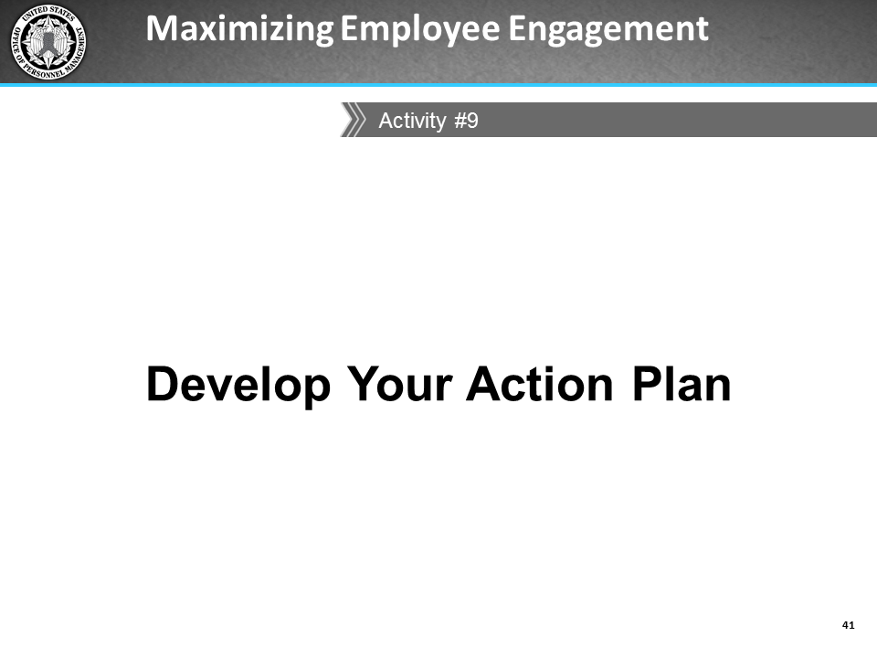
Notes:

Activity: Develop Your Action Plan
For this final activity you will indicate specific actions you will take to overcome engagement barriers and improve levels of engagement among your employees. Think about the level of engagement you want to achieve for yourself and your team in the near term (i.e., 6 months to a year) and long-term (i.e., within 1 to 2 years). You will identify at least 3 specific engagement challenges and develop a plan of action for each. The challenges do not have to be listed in order of priority. Refer to the notes you have taken throughout this course to give you some ideas, such as factors that keep you engaged, the results of your assessment of your primary management style, things that you identified as organizational barriers, strategies from other government agencies, as well as any other notes from the rest of the slides and other activities. You will document this in the table on the next page.
Account for the following factors when developing a comprehensive action plan:
- Specific challenge related to engagement
- Target (self, individual, or group)
- Actions you can take within your role as a supervisor or manager
- Resources you will need (e.g., staffing, training, opportunity outside work unit)
- Communication plan - who to talk with to make this work (boss, employee, group, HR/HCM)
- Completion -you must be prudent in following up with your action plan and marking off successes
After identifying at least 3 specific challenges and actions you are going to take to address them, you may share some of the details of your Action Plans—within your comfort level—with the rest of the class. The class will provide feedback and suggestions for addressing the challenges.

Your Action Plan
Challenge | Target | Action to be Taken | Due Date | Resources (e.g., money, staff) | Communication (who should know) | Completed (yes/no)

Conclusion
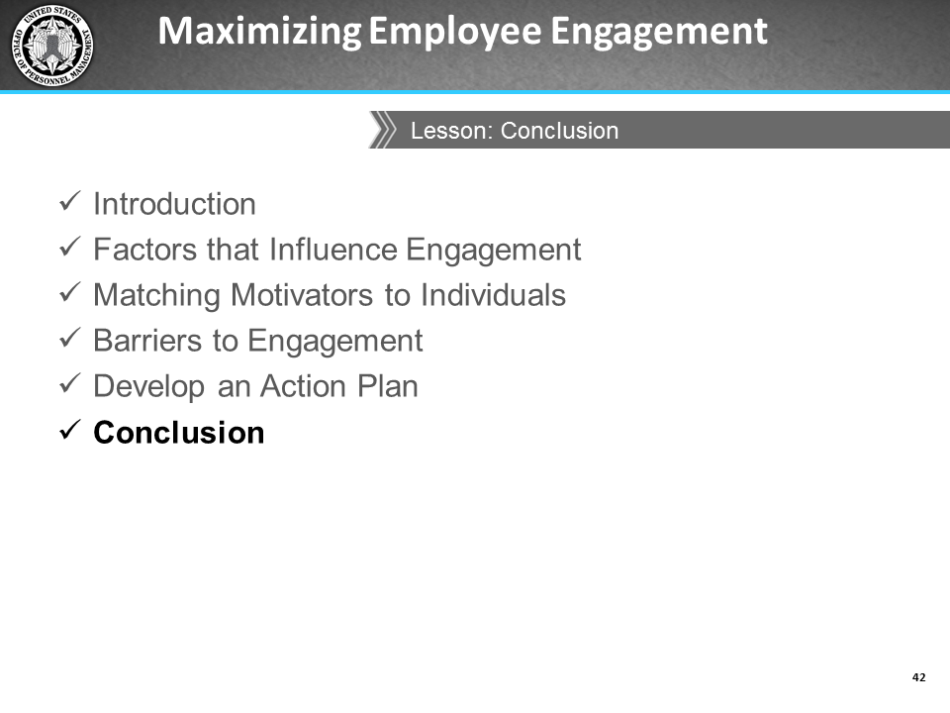
Notes:
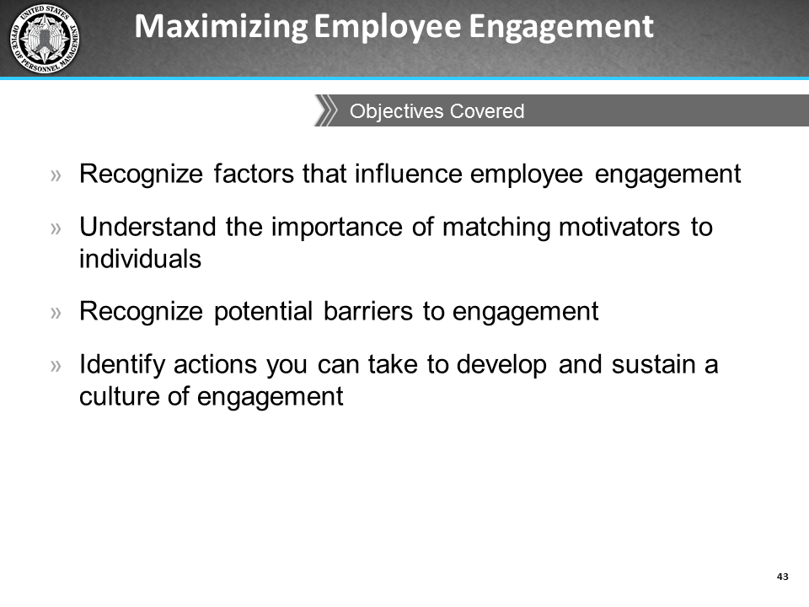
Notes:
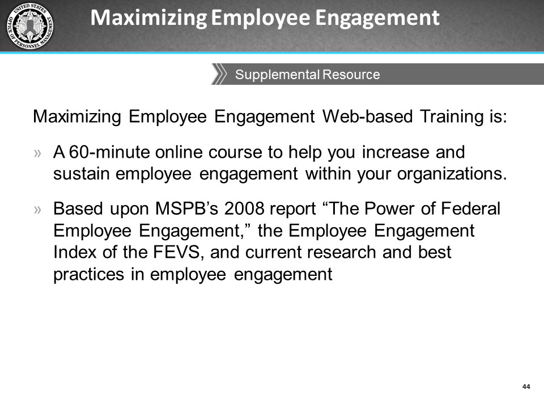
Notes:

Section 2: Job Aids

This page left intentionally blank.

Job Aid: Debunking Myths about Employee Engagement
Myth | Reality
Compensation is the biggest driver of employee engagement | - Compensation is important, but not a main driver of employee engagement.  - A sense of purpose about why the agency exists and its contribution to society is a bigger driver for employees than compensation.  - A sense of participation with the agency (e.g., recognition and rewards, opportunities to grow, and involvement) is a bigger driver for employees than compensation.
The drivers of engagement are the same across agencies | - Drivers of employee engagement across various organizations are more different than they are similar, even if they are within the same industry.  - Each agency's culture differs and drivers at your agency may not be drivers at another because of the differences in organizational culture, work focus, and types of employees.
Employee engagement is hosting an event every now and then | Effective employee engagement should be in everything the agency does; it must be integrated and embedded into the agency’s strategic planning, HR and talent management planning, organizational culture and values, and so on.
The best agency leaders are all great at inspiring employees | The best agency leaders might not necessarily be viewed as the most inspirational leaders. However, they have the capability to ensure employees have the right resources and tools to perform their jobs consistently and get the best results (e.g., engagement, performance, retention) from their employees.
Employee engagement is HR’s responsibility | - HR's role is to help managers maximize engagement with their teams by providing tools, resources, and talking points that enable managers to have meaningful conversations with their employees.  - Employee engagement happens on every level, must be owned by everyone in the organization, and must start at the top and filter through the agency.  - Employee engagement defines the success (or downfall) of an entire company. An engaged workforce is a major factor in achieving agency goals.  - Paying (more) attention to engagement is time well spent, even for the busiest executive, manager, and supervisor.

Job Aid: Ways to Create a Culture of Engagement
The following are quick actions and the ways to execute those actions to help create a culture of engagement in your organization.
Action | How to Create a Culture of Engagement
Instill a sense of pride in the work or workplace | - Use the performance management process to communicate to employees how their work contributes to achieving agency objectives. Performance meetings provide an opportunity to establish an alignment between the employee's role and the agency mission and goals.  - Encourage employees to take ownership of their work.
Create a sense of trust and transparency with leadership | - Communicate a clear vision of how the agency will accomplish its mission.  - Communicate honestly about the organization and ensure your words are consistent with your actions.  - Ensure there is transparency between decisions and the strategic direction of the organization.
Provide the opportunity to perform well at work | - Provide frequent informal or formal performance feedback and discussions.  - Hold employees accountable for results through a structured performance management process.  - Ensure that employees' job responsibilities make good use of their competencies and that they are provided with the resources, time, and assistance needed to perform their jobs.
Provide reward and recognition consistently and frequently | - Take time to validate and acknowledge employee achievements.  - Integrate rewards and recognition into how employees are managed on a day-to-day basis.
Provide opportunities for personal and professional growth | - Demonstrate an interest in developing and mentoring employees.  - Help employees assess, fine-tune, and develop new skills.  - Give employees specific goals as well as the training, tools, and resources for employees to perform their job.  - Use a competency-based approach to ensure their skills are well-used and continually enhanced.
Create a positive work environment that also focuses on teamwork | - Create opportunities for team members to interact and work together.  - Actively solicit feedback and satisfaction and incorporate their thoughts and ideas into the agency operation.

This page left intentionally blank.

Job Aid: Fast Track to Lowering Engagement
The following are some of the quickest ways to lower engagement amongst your employees.
- Failing to provide transparent and trustworthy senior leadership.
- Failing to communicate openly, frequently, and effectively with employees about organizational challenges, as well as organizational achievements.
- Failure to have open two-way communication with the workforce, to include communicating with employees as a group and on an individual basis.
- Failing to include and solicit feedback from employees in developing strategies and recommendations for agency improvements.
- Failing to have senior leaders take an active interest in EVS results and develop agency-wide and office plans for improvements.
- Failing to empower employees to be innovative and find ways to better perform their jobs.
- Failing to provide the right tools and resources for employees to effectively do their jobs.
- Failing to communicate a clear vision of the agency's mission and helping employees see line-of-sight between their work and the agency's mission.
- Failing to provide opportunities for career advancement and provide greater responsibilities or new experiences.
- Failing to recognize and acknowledge good work.
- Failing to appropriately reward or promote employees.
- Failing to include employee engagement as a performance metric in managers' performance plans.
- Failing to incorporate team problem-solving and decision-making, especially where it affects them.
- Failing to tailor engagement efforts to the culture/climate of your agency.

This page left intentionally blank.

Job Aid: Other Government Agencies’ Strategies to Drive an Engaged Organizational Culture
The following government agencies shared with OPM what they do to maximize employee engagement within their organizations:
- Department of Education (ED)
- Department of Human Services (DHS)
- National Aeronautics and Space Administration (NASA)
- National Institutes of Health (NIH)
- Nuclear Regulatory Commission (NRC)
- Office of Management and Budget (OMB)
- Office of Personnel Management (OPM)
- United States Coast Guard (USCG)
While not all of these will work within your agency because of the different organizational culture (e.g., mission, union), you should still be able to find a few ideas that will be well-suited and relatively easy to adopt and practice within your team. Implementing these or similar ideas could have a positive influence on your agency's engagement levels, and ultimately, FEVS engagement scores.
Employees
Ideas Involving Employees | What it looks like
Create a “Morale Committee” | Create a committee that develops and enacts ideas to make staff feel appreciated (e.g., promoting health and wellness activities, providing non-monetary rewards).
Recognize Other Staff | Encourage staff to nominate coworkers for good work. Employees select who wins the awards, which promotes a sense of pride by being nominated by their peers.
Practice the Servant Leadership Model | Focus on helping others and modeling good leadership.
Get Together Outside Work | Schedule activities such as bowling, and movies to help bring teams together.

Supervisors and Managers
Activities Supervisors and Managers Can Do | What it looks like
Create Teambuilding Activities | Many offices hold division level retreats and seminars that include all divisional staff. These meetings typically focus on topics of interest to the division and often include segments that are used to identify ways to improve the operation of the organization.
Bring Food into the Equation | Supervisors or managers bring in food (e.g., pizza, cupcakes) for employees during group meetings. Managers take their staff out for lunch just because they want to; staff can see that the manager enjoys doing it and that it is authentic and not forced.
Develop and Monitor Individual Development Plans (IDPs) | As part of the performance process, employees and their supervisors discuss their IDPs. This includes discussing goals, performance expectations, and things they will do throughout the year.
Give Employees the Opportunity to Select their Own Assignments | Encourage employees to express interest in and volunteer to work on specific projects.
Encourage and Model Work-life Balance | Managers model this by not always staying late or always working on weekends. They also publicly support work-life programs such as telework, Employee Assistance Program (EAP), or health and fitness programs, as appropriate.
Create Lateral and Rotational Assignments | Staff is frequently assigned collateral duties on teams, working groups, and steering committees that allow the individual to work on tasks that are outside their routine. These assignments are helpful in instilling ownership, inclusion, and a sense of collaboration for the staff and their respective offices.
Take Opportunities to Provide Positive Feedback | Give positive reinforcement and feedback.

Executives’ Actions
Actions Executives Can Take | What it looks like
Set up Monthly Focus Groups to have “Diversity Dialogues” | Focus on dialogues about age, race, gender, disability, etc. for employees to become more knowledgeable about differences and similarities in behaviors, communication styles, values, etc., as well as become more comfortable with different types of employees.
Encourage Leaders to be More Visible and Accessible | Walk around the office, be seen, and make eye contact. Demonstrate the organization’s values and competent, approachable, and personable leadership. Have a monthly “Coffee with an Executive” or “Lunch with an Executive” that offers an opportunity for participants to discuss a list of current questions/issues.
Develop an “Idea Factory” to Solicit Ideas from Employees | Set up an automated system to actively solicit ideas about ways to improve organizational challenges from employees, where one employee can build on what another suggests. Some agencies recognize employees who have provided ideas by having senior leaders introduce them during town halls and ask them to describe their ideas to everyone. Senior leaders sign on to act as champions for the ideas, which helps break down communication and accessibility barriers between leaders and employees.
Provide Guidance on Effective Performance Management Systems | Assist leaders and employees to learn more about how to make the most of the performance management process. One agency developed a booklet that presents role plays and frequently asked questions that can help both the employee and the supervisor get into the mode for performance appraisal and discussion about developmental opportunities. Agency-sponsored workshops for supervisors or managers also provide an opportunity for them to learn how to recognize and reward employees.
Create a Monthly Newsletter | Solicit input from employees about both official and personal events (e.g., voluntary efforts or commemorative events) to include in a newsletter.
Host Quarterly/Yearly Town Halls | Use town halls and all-hands meetings to keep employees informed and to obtain input from them.

Executives’ Strategies
Strategies for Executives | What it looks like
Advertise and Promote the Mission and Values of the Organization | Create unrehearsed videos in which employees state what the organizational values mean to them. Display quotes on a banner at the entrance of the building along with the mission and values of the organization.
Create a Clear and Open Communication Strategy | Hold staff meetings soon after senior staff meetings. This helps control flow of information rather than contributing to rumors, and establishes consistent and open communication.
Practice Situational Leadership Approach | Have the most knowledgeable person about an issue in the room present to others, rather than have the most senior person do it.
Develop an “Innovation Lab” | Hold sessions used to tackle organizational issues, emphasizing innovation and creating energy among employees. Other departments are invited to join, and any employee can be a facilitator.
Create a “Solicitations of Interest” System | Set up an internal system where supervisors who need extra staff can ask for it. Half-page announcements are emailed to employees weekly so they can see what work is coming up and apply for it. Employees can apply directly for the work; they do not need to go to HR for a formal assignment. Assignment length may range from a couple of months to six months. They can also be part time, such as two hours a week for two months.
Encourage Employees to Develop Action Plans to Respond to FEVS Results | Form Advisory Teams of employees to determine how to address the areas identified by survey results as needing improvement. Employees develop action plans for specific areas; they collect information/data and assist in the implementation of the response. Senior leaders keep employees updated on progress (via agency-wide conference calls, town halls, newsletters, emails, etc.).
Emphasize Continuous Learning | Leadership supports a proactive, assertive, leaning forward attitude and provides continual training and development to employees, through formal training, developmental assignments, details, and lateral assignments to new positions.
Encourage Managers to Get Together and “Talk” | Supervisors and managers meet with each other, and then meet with managers at the level above them on a monthly basis to discuss topics of interest. Any relevant information from these meetings is then fed back to the staff to increase the sharing of information.
Encourage Honest Conversations Between Supervisors and Employees | Encourage honest conversations about what the supervisor can do to make the employee want to contribute his or her best talent. Honesty can increase feeling of trustworthiness and make employees feel that their supervisor has their best interest at heart and will not use information shared in confidence against them.

This page left intentionally blank.

Job Aid: Alternative Non-monetary Ways to Encourage Training and Development
Encourage inquiry and a sense of constant curiosity
- Encourage a seminar series that provides opportunities for employees to give presentations about their various areas of expertise to other employees.
- Collaborate with other managers to act as panel experts for discussions or presentations and lend knowledge to panel discussions on various topics. Invite employees to these forums, allowing them to ask questions and gain new knowledge.
- Encourage employees to spend time interviewing other employees or managers in other sectors about their work. Dedicate a specific number of hours each quarter to allow your employees to conduct these informational interviews.
Encourage service and volunteerism
- Encourage employees to volunteer within their communities to further develop their particular skill sets, and also develop leadership skills by taking on leadership roles within their communities.
Encourage inter-departmental learning
- Promote resources already available in the organization by inviting employees who have a variety of skill sets or belong to other offices to collaborate and work on projects together.
- Organize informal interdepartmental get-togethers during lunch, breaks, or brown bag sessions to discuss, build relationships, and build communities of practice.
Encourage Employees to find a mentor
- Talk to your employees to find out which of them are interested in mentoring or even job shadowing. Then think about who would make good matches to provide both parties with developmental opportunities.
- Be a facilitator in helping employees form relationships with other individuals, such as supervisors, managers, or executives you have access to.
- Use mentoring to get older and younger employees talking, such as sharing knowledge and ideas and combining perspectives in new and interesting ways.

This page left intentionally blank.

Section 3: Supplemental Reading and References

This page left intentionally blank.

Supplemental Reading
Albrecht, S. L (Ed.). (2010). Handbook of employee engagement: Perspectives, issues, research and practice. Northampton, MA: Edward Elgar Publishing, Inc.
Ayers, K. (n.d.) The high cost of a lack of engagement. Retrieved Dec 3, 2012, from http://www.engagementisnotenough.com/pdfs/Cost_of_Engagement.pdf
Bakker, A., & Leiter, M. (2010) Work engagement: A handbook of essential theory and research. New York, NY: Psychology Press.
Carbonarra, S. (2013). Manager’s guide to employee engagement. New York, NY: McGraw Hill.
Catlette, B., & Hadden, R. (2912, Aug 17). How to foster outrageously awesome employee engagement. Fast Company. Retrieved from http://www.fastcompany.com/3000474/how-foster-outrageously-awesome-employee-engagement
Cook, S. (2008). The essential guide to employee engagement. London, UK: Kogan Page.
Employee Engagement Report. (2011). BlessingWhite North America. http://www.blessingwhite.com/%5Ccontent%5Creports%5C2008EmployeeEngagementNAOverview.pdf
Employee Engagement Report. (2011). BlessingWhite North America. Retrieved from http://www.blessingwhite.com/content/reports/blessingwhite_2011_ee_report.pdf
Haudan, J. (2008). The art of engagement: Bridging the gap between people and possibilities. New York, NY: McGraw Hill.
Kahn, W. A. (1990). Psychological conditions of personal engagement and disengagement at work. Academy of Management Journal, 33(4): 692-724.
Kruse, K. (2012). Employee engagement 2.0: How to motivate your team for high performance. Richboro, PA: The Kruse Group.
Macey, W., Schneider, B., Barbera, K., & Young, S. (2009). Employee engagement: Tools for analysis, practice, and competitive advantage. Chichester, UK: Wiley Blackwell.
MacLeod, D., & Brady, C. (2008). The extra mile. London, UK: FT Prentice Hall.
Vance, R.J. (n.d.) Employee Engagement and Commitment: A guide to understanding, measuring and increasing engagement in your organization. SHRM Foundation: Alexandria, VA. Retrieved from http://www.shrm.org/about/foundation/products/Pages/EmployeeEngagement.aspx

References
Albrecht, S. L (Ed.). (2010). Handbook of employee engagement: Perspectives, issues, research and practice. Northampton, MA: Edward Elgar Publishing, Inc.
Attridge, M. (2009). Employee work engagement: Best practices for employers. Research Works: Partnership for Mental Health. 1, 1-12.
Bakker, A., & Leiter, M. (Eds.) (2010). Work engagement: A handbook of essential theory and research. New York, NY: Psychology Press.
Bassi, L. (2012, May 3). Debunking employee engagement myths. Retrieved from http://www.astd.org/Publications/Blogs/Learning-Executive-Blog/2012/05/Bassi-6-Debunking-Engagement
Blake, R. R., & Mouton, J. S. (1964). The managerial grid. Houston, TX: Gulf Publishing Company.
Branham, L. (2001). Keeping the people who keep you in business. Soundview Executive Book Summaries, 22(1). Retrieved from http://www.abp-corporation.com/abpportal/biblioteca/ExecSummaries-Keeping_the_People.pdf
Branham, L. (2005). The 7 hidden reasons employees leave: How to recognize the subtle signs and act before it's too late. New York, NY: AMACOM Books.
Campion, M., & Thayer, P. (1987). Job design: Approaches, outcomes, and trade-offs. Organizational Dynamics, 15, 66‑79.
Carbonarra, S. (2013). Manager’s guide to employee engagement. New York: McGraw Hill.
Classle. (n.d.) Interpersonal barriers in communication. Retrieved from https://www.classle.net/content-page/interpersonal-barriers-communication#
Cook, S. (2008). The essential guide to employee engagement. London: Kogan Page.
Employee Performance Management Workgroup (2011, Nov). Goals-Engagement-Accountability-Results: Getting in GEAR for Employee Performance Management. Report to the National Council on Federal Labor-Management Relations
Employee Engagement Focus Groups and Interviews. (2013, Jan 30). [Interview]. Chris McLaren, Office of Management and Budget, Washington, DC.
Employee Engagement Focus Groups and Interviews. (2013, Feb 14). [Interview]. Christine Heflin, Department of Commerce, Washington, DC.
Employee Engagement Focus Groups and Interviews. (2012, Dec 5). [Focus group]. Representatives of OPM, Nuclear Regulatory Commission, US Coast Guard, and Department of Energy. Office of Personnel Management, Washington, DC.
Garlick, R. (2007). Managing your boss: The impact of manager personality and style on employee performance. Hospitality.Net. Retrieved Jan 8, 2013 from http://www.hospitalitynet.org/news/4032781.html
Goleman, D. (2000). Leadership that gets results. Harvard Business Review, 78(2), 78-90.
Goleman, D. (1998). What makes a leader? Harvard Business Review, 76(6), 93-102.
Goleman, D., Boyatzis, R., & McKee, A. (2001). Primal leadership: The hidden driver of great performance. Harvard Business Review, 79(11), 42-51.
Haudan, J. (2008). The art of engagement: Bridging the gap between people and possibilities. New York: McGraw Hill.
Kahn, W. A. (1990). Psychological conditions of personal engagement and disengagement at work. Academy of Management Journal, 33(4), 692-724.
Lindner, J. R. (1998). Understanding employee motivation. Extension Journal, 36 (3). Retrieved from http://www.joe.org/joe/1998june/rb3.php
Macey, W., Schneider, B., Barbera, K., & Young, S. (2009) Employee engagement: Tools for analysis, practice, and competitive advantage. Chichester: Wiley Blackwell.
MacLeod, D., & Brady, C. (2008). The extra mile. London: FT Prentice Hall.
Miller, J. (2012, Dec 14). Highest ranked agencies distinguished by strong leadership. Retrieved from http://www.federalnewsradio.com/204/3156902/Highest-ranked-agencies-distinguished-by-strong-leadership
Northouse, P.G. (2007). Leadership theory and practice. Thousand Oaks, CA: Sage Publications, Inc.
O’Connell, M. (2012, Dec 13). ‘Best Place to Work?’ —Not so much. Retrieved from http://www.federalnewsradio.com/204/3155352/Best-Place-to-Work----Not-so-much
Seshadri, S. (2010, July 7). Six myths of employee engagement. Retrieved from http://www.executiveboard.com/blogs/six-myths-of-employee-engagement/
Suharti, L., & Suliyanto, D. (2012, Sep). The effects of organizational culture and leadership style toward employee engagement and their impacts towards employee loyalty. World Review of Business Research, 2(5), 128-130.
U.S. Merit Systems Protection Board. (2012, Dec). Federal employee engagement: The motivating potential of job characteristics and rewards. http://www.mspb.gov/netsearch/viewdocs.aspx?docnumber=780015&version=782964
U.S. Merit Systems Protection Board. (2008, Sep). The power of Federal employee engagement. Retrieved from http://www.mspb.gov/netsearch/viewdocs.aspx?docnumber=379024&version=379721
U.S. Merit Systems Protection Board, (2009, July). Managing for engagement—Communication, connection, and courage. Retrieved from http://www.mspb.gov/netsearch/viewdocs.aspx?docnumber=437591&version=438697&application=ACROBAT

Source: U.S. Merit Systems Protection Board. (2012, Nov). Federal employee engagement: The motivating potential of job characteristics and rewards.
Source: Goleman, D. (2000). Leadership that gets results. Harvard Business Review, 78(2), 78-90.
Source: Bassi, L. (2012, May 3). Debunking employee engagement myths. Retrieved from http://www.astd.org/Publications/Blogs/Learning-Executive-Blog/2012/05/Bassi-6-Debunking-Engagement/ Seshadri, S. (2010, July 7). Six myths of employee engagement. Retrieved from http://www.executiveboard.com/blogs/six-myths-of-employee-engagement/
Source: Miller, J. (2012, Dec 14). Highest ranked agencies distinguished by strong leadership. Retrieved from http://www.federalnewsradio.com/204/3156902/Highest-ranked-agencies-distinguished-by-strong-leadership O’Connell, M. (2012, Dec 13). ‘Best Place to Work?’ —Not so much. Retrieved from http://www.federalnewsradio.com/204/3155352/Best-Place-to-Work----Not-so-much Employee Engagement Focus Groups and Interviews. (2012, Dec 5). [Focus group]. Office of Personnel Management, Washington, DC.
Source: Coro Fellows Program in Public Affairs. (2013, Mar 22). With GSA Canceling Trainings, How Can Feds Develop New Skills? Retrieved from http://www.govexec.com/excellence/promising-practices/2013/03/gsa-canceling-trainings-how-can-feds-develop-new-skills/62004/#.UVBNyU6CY0Y.email

