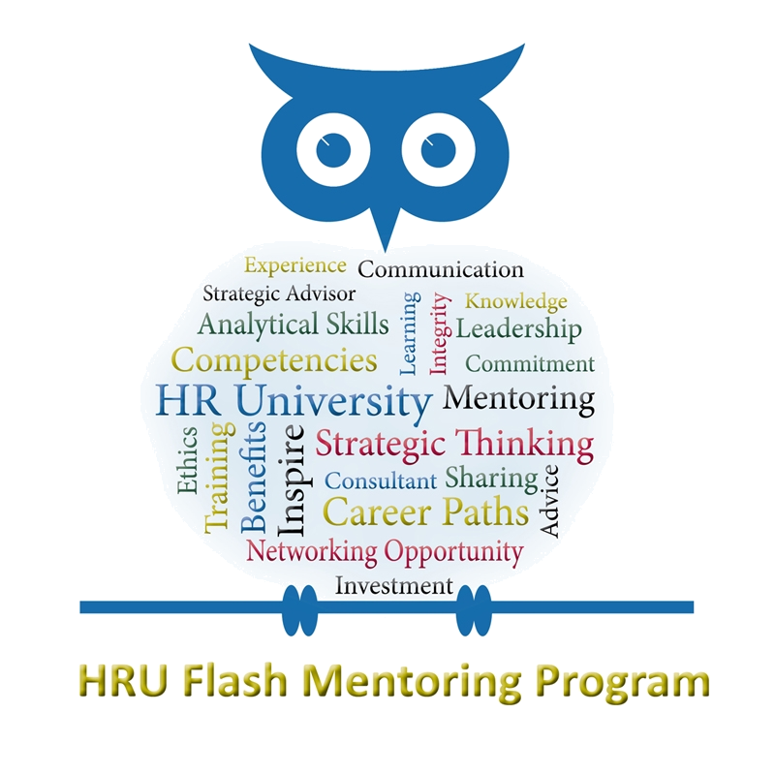

MENTOR DISCUSSION TOPICS
Workforce Planning for Emerging HR Leaders: Developing technical and leadership skills to manage Federal HR Initiatives
Mentors: Thank you for volunteering to participate in the November 2012 CHCOC Flash Mentoring Event! Your experience, enthusiasm and willingness to share with staff at the GS 13-15 level is a critical part of today’s event. We are asking that you address three rounds of mentees for 30 minutes each with each round focusing on a different theme. The following list of suggestions provides three starter questions for each round. We also encourage you to engage your table in conversation by asking them for their thoughts/questions on each topic.
- Round 1 – Business Acumen: Workforce Planning and Why it matters
Workforce Planning — Knowledge of HR concepts, principles, and practices related to determining workload projections and current and future competency gaps to align human capital with organizational goals.

- How do you engage managers in workforce planning discussions so that they honestly assess their needs versus their wants?
- Talk about your experiences as a manager regarding how you learned about Workforce Planning and how you integrate it into your daily activities.
- What advice do you have for emerging HR leaders when it comes to planning for the future Federal workforce?

- Round 2 – Problem Solving: Doing More with Less

Problem Solving — Identifies problems; determines accuracy and relevance of information; uses sound judgment to generate and evaluate alternatives, and to make recommendations.
- Describe your experience managing budgets and resources and how this skill is important to HR leaders.
- What advice do you have for staff who are looking to develop their budget/finance skills? Do you have any specific courses or developmental assignments you can recommend that helped you along your career?
- How can HR leaders help Agencies improve morale during times of fiscal restraint?

- Round 3 – Leading Change/Building Coalitions: Improving relations with Hiring Managers and the Workforce

Leading Change - This core qualification involves the ability to bring about strategic change, both within and outside the organization, to meet organizational goals. Inherent to this ECQ is the ability to establish an organizational vision and to implement it in a continuously changing environment.
Building Coalitions - This core qualification involves the ability to build coalitions internally and with other Federal agencies, State and local governments, nonprofit and private sector organizations, foreign governments, or international organizations to achieve common goals.
- Share an example where you had to work across department and/or agency lines to enact change that benefit the workforce.
- Discuss how your relationships with hiring managers and your workforce has led to your ability to better affect change within your agency.
- Do you have any favorite books or trainings that would help emerging leaders reach the next level in leading change and building coalitions?

